https://www.bilibili.com/video/av47030279

第1课-如何建立信任

1.

everyone is a business person. have you ever decided the schedule with your roommate? that's negotiation. have you ever told someone else about yourself on a first date? i know it's uncomfortable. but that's an elevator pitch. have u organized a ? and engage all your friends? congratulations! u just ? an event and hold the management position. ?? day to day business. look for a job and really take your career to the next level. truning in to a bussiness role do wear a suit ? we hope you to succeed on you own terms and identify what is best for you. in bussiness world, we competency. what makes you special really . we need to set down and have a chat about trust. this is crashcourse business soft skills.

trust may seem like a basic idea,but actually a challenging and fundamental concept. business pyramid not pyramid skin. trust makes the basis of your competence, which is fundamental of working relationships, progressions and job offer. by whoom you trusted is depend on who you think is competent. it depends on your experience with them, how they act ,what they say and what decisions they made. who??? fireplace???. will you trust your high school classmate for ??? or your roommate for just rupt from tuesday's class

2.

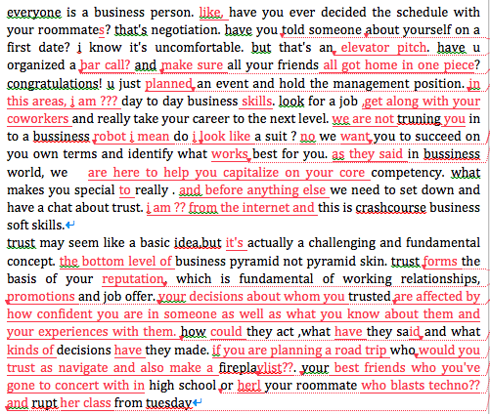

3.

everyone is a business person. like, have you ever decided on a chore schedule with roommates? that's negotiation. have you told someone about yourself on a first date? i know it's uncomfortable. but that's an elevator pitch. have u organized a bar crawl and made sure your friends all got home in one piece? congratulations! you've just planned an event and held a management position. so in this series, we are going to help you hone those day to day business skills. look for a job ,get along with your coworkers and really take your career to the next level. we are not truning you in to a bussiness robot i mean do i look like a suite ? no we want you to succeed on you own terms and identify what works best for you. as they say in bussiness world, we are here to help you capitalize on your core competency. or use what makes you special to really strut your stuff. and before anything else we need to sit down and have a chat about trust. i am ?? from the internets and this is crashcourse business soft skills.

trust may seem like a basic idea,but it's actually a challenging and fundamental concept. like the bottom level of business pyramid not a pyramid scheme. trust forms the basis for your reputation, which is fundation of working relationships, promotions and job offer. your decisions about whom to trusted are affected by how confident you are in someone as well as what you know about them and your experiences with them. how could they acted ,what have they said and what kinds of decisions have they made. if you are planning a road trip who would you trust to navigate and also make a fire playlist. your best friends who you've gone to concerts with in high school or her roommate who blasts techno and wrecked his car last tuesday

message：

* bussiness skills are useful and can be applied in everyday situations
* building trust is the fundation of bussiness skills because trust affects others' decisions.

listen：

chore schedule : [tʃɔːr] 家务安排表

bar crawl [krɔːl]爬→酒局

hone [hoʊn] 磨刀，磨炼（技能）

strut your stuff [strʌt] 趾高气扬地走→大显身手

pyramid scheme 非法传销（金字塔骗局）

blasts techno一种利用电子技术演奏的节奏鲜明的舞曲→搞电子音乐

speak：

安然无恙的 in one piece

搞坏车wrecked his car

电梯演讲elevator pitch

承担管理者held a management position

提升事业 take your career to the next level.

以自己的条件on you own terms

充分利用capitalize on

核心竞争力core competency